REPORT ON

Discover Innovation and Design Thinking for Growth
Organized by: Department of Commerce and IIC
Date: 20th February 2026
Venue: MBA Conference Hall
Time: 9:30 AM onwards
Stakeholders: 50 Students from MCA, B.Com, and BBA

The Department of Commerce in association with IIC organized an insightful session on “Discover Innovation and Design Thinking for Growth” on 20th February 2026 at the MBA Conference Hall from 9:30 AM onwards. The session aimed to enhance students’ understanding of innovation, structured creativity, and business growth strategies.
A total of 50 students from MCA, B.Com, and BBA actively participated in the program.

The session commenced with a formal inauguration ceremony graced by distinguished dignitaries:
- Fr. Dr. Lourd Prasad, Rector
- Rev. Fr. David Sagayaraj
- Ravi J D Saldhana, Principal
- Dr. Noor Mubashir, P.G. Coordinator
- Dr. Reena Francis, Dean, Faculty of Commerce
The gathering was warmly welcomed by the Convenor, Juhie Singh P, Assistant Professor, who highlighted the importance of innovation and design thinking in today’s competitive business environment.
The guest speaker was formally introduced by Dr. Divya, who briefed the audience about his achievements and contributions in the field of innovation.
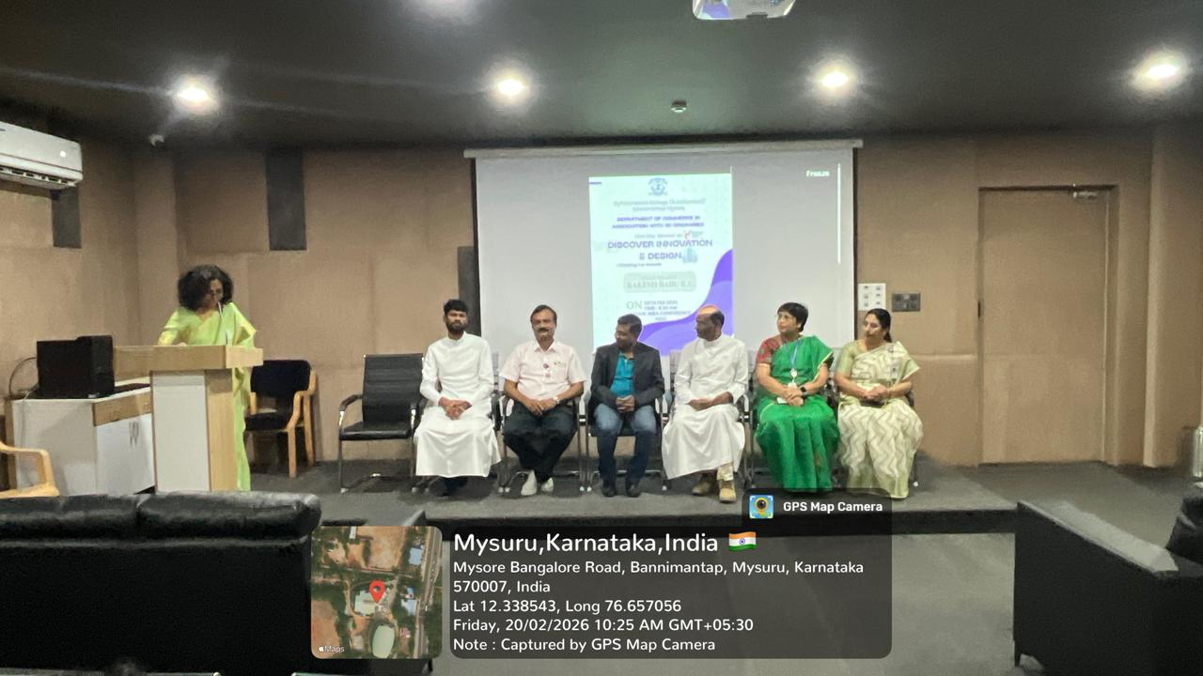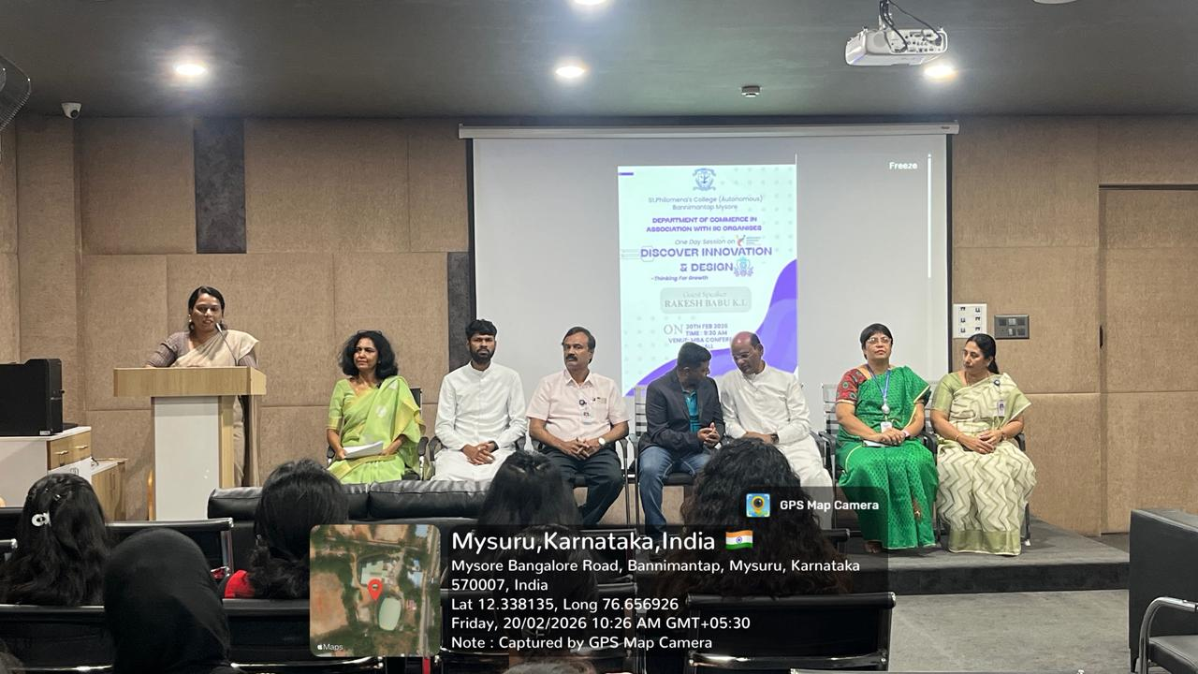

Guest Speaker Profile
The session was delivered by Rakesh Babu K L, COO and Executive Director of InnomAntra Consulting Private Limited.
He is the co-developer of the Functional Innovation Methodology, a systematic approach for product, process, and business model innovation. Since 2011, he has trained over 2,500 innovators across various sectors, contributing significantly to the innovation ecosystem. 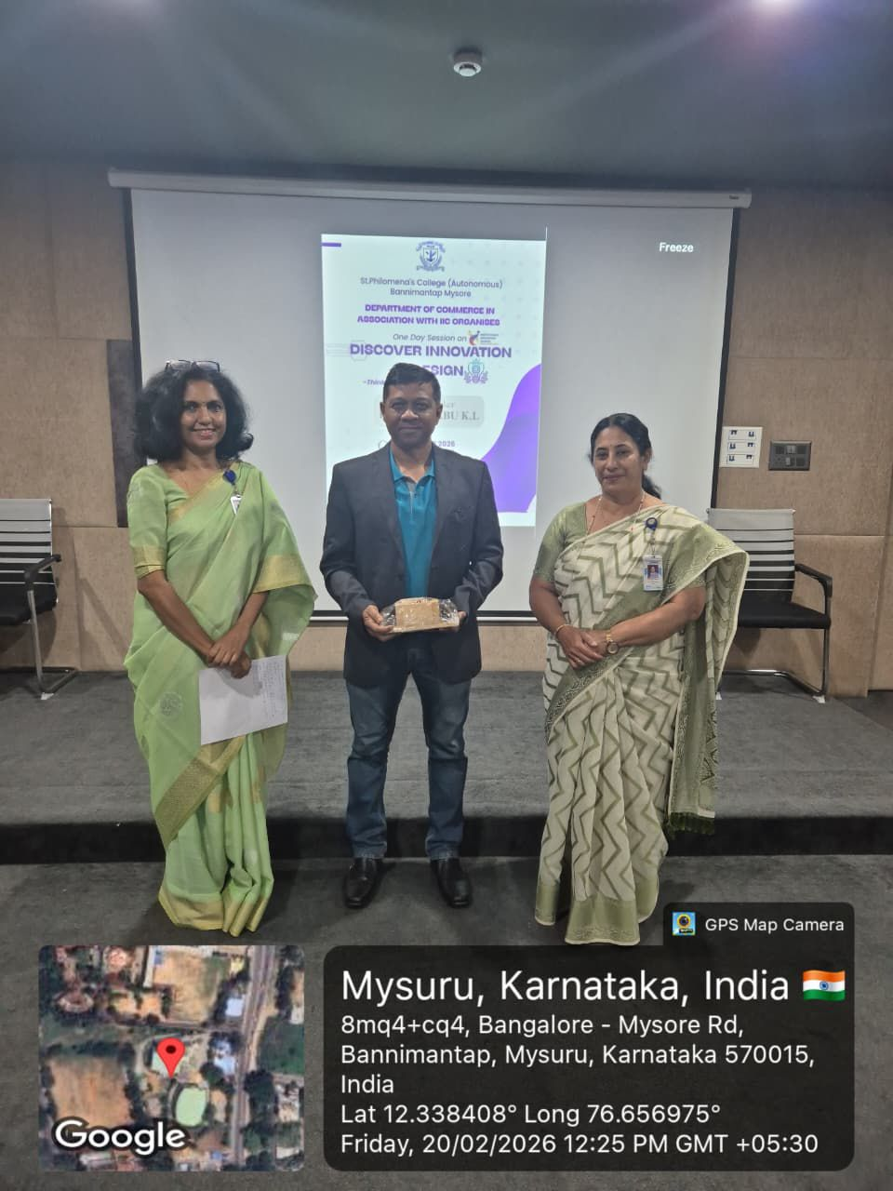

Highlights of the Session
The session focused on the following key areas:

1. Understanding Innovation
The speaker explained that innovation is not just about creativity but about delivering value through structured processes. He emphasized innovation in products, services, processes, and business models.

2. Design Thinking for Growth
He elaborated on design thinking as a human-centered approach that helps organizations identify real customer problems and create effective solutions.

3. Functional Innovation Methodology
The methodology discussed provided a systematic framework for:
- Identifying problem statements
- Generating structured ideas
- Evaluating feasibility
- Developing scalable business solutions

4. Practical Insights
Real-world examples and case discussions helped students understand how innovation can drive business growth and competitive advantage.

5. Interactive Engagement
The session was highly interactive, with students actively participating in discussions and asking insightful questions regarding entrepreneurship and innovation careers.

5. Learning Outcomes
The program enabled students to:
- Understand structured innovation frameworks
- Recognize the importance of design thinking in business
- Develop problem-solving skills
- Gain exposure to real-world innovation practices
- Build entrepreneurial mindset
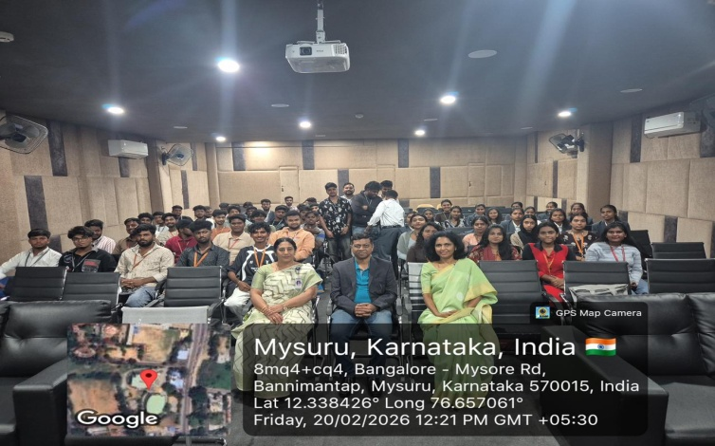

6. Conclusion
The session on “Discover Innovation and Design Thinking for Growth” was highly informative and inspiring. It provided students with valuable insights into systematic innovation and its role in driving organizational growth.
The Department of Commerce and IIC successfully organized a meaningful academic event that enriched students’ knowledge and encouraged innovative thinking for future career development.

