ALUMNI FEEDBACK ON CURRICULUM — 2025
11th Convocation | St. Philomena's College (Autonomous) | Mysuru – 570 015
Internal Quality Assurance Cell (IQAC) | Affiliated to the University of Mysore

The Internal Quality Assurance Cell (IQAC) of St. Philomena's College (Autonomous) collected alumni feedback on the curriculum during the 11th Convocation — 2025. A total of 26 alumni across seven programmes (B.Sc., M.Sc. Biochemistry, B.A., M.Sc. Computer Science, M.Sc. Physics, B.Com., and B B A.T.H.) participated in this feedback exercise. The survey comprised 10 components covering curriculum quality, learning outcomes, and convocation experience. Additionally, alumni provided information on their present employment or educational status and suggestions for curriculum improvement.
1. RESPONDENT PROFILE

26  Total Respondents | 17  Female Alumni | 9  Male Alumni | 11  In Higher Education | 11  Employed | 4.32  Grand Mean
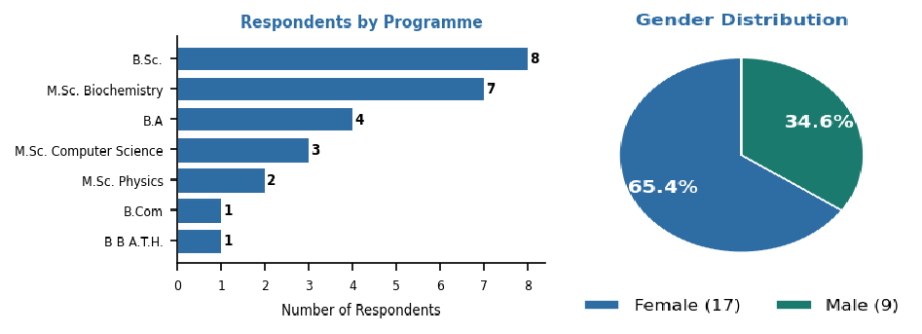
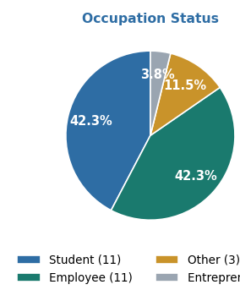

Employment / Higher Education Status of Respondents

Present Status | Count | Percentage (%)
Higher Education Studies | 12 | 46.2%
Quality Control/Quality Analyst | 4 | 15.4%
Self Employed | 4 | 15.4%
Medical consultant | 1 | 3.8%
Teacher | 1 | 3.8%
Asst. Professor | 1 | 3.8%
Assistant professor | 1 | 3.8%
Employee | 1 | 3.8%
Lecturer | 1 | 3.8%
Note on K-SET/NET Qualification: The K-SET/NET qualification field was included in the survey; however, all 26 respondents left this field blank, indicating that none of the participating alumni had qualified for K-SET or NET at the time of the convocation. This is expected as the majority of respondents are recent graduates. The institution is encouraged to track K-SET/NET qualification rates in subsequent alumni surveys.

2. OVERALL FEEDBACK SUMMARY

Q# | Curriculum Component | N | Mean | SD | Excellent | Very Good | Good | Satisf. | Poor | Remarks
Q1 | Depth of Course Content | 26 | 4.27 | 0.874 | 14 (54%) | 5 (19%) | 7 (27%) | 0 (0%) | 0 (0%) | Not Reqd.
Q2 | Coverage of Syllabus | 26 | 4.35 | 0.892 | 16 (62%) | 3 (12%) | 7 (27%) | 0 (0%) | 0 (0%) | Not Reqd.
Q3 | Relevance for Employment / Higher Education | 26 | 4.31 | 0.884 | 15 (58%) | 4 (15%) | 7 (27%) | 0 (0%) | 0 (0%) | Not Reqd.
Q4 | Learning Values (Knowledge, Skills, Analytic | 26 | 4.31 | 0.884 | 15 (58%) | 4 (15%) | 7 (27%) | 0 (0%) | 0 (0%) | Not Reqd.
Q5 | Clarity and Relevance of Reading Material | 26 | 4.35 | 0.892 | 16 (62%) | 3 (12%) | 7 (27%) | 0 (0%) | 0 (0%) | Not Reqd.
Q6 | Availability of Study Material and Library Books | 26 | 4.27 | 1.002 | 16 (62%) | 2 (8%) | 7 (27%) | 1 (4%) | 0 (0%) | Not Reqd.
Q7 | Relevance of the Curriculum | 26 | 4.31 | 0.928 | 16 (62%) | 2 (8%) | 8 (31%) | 0 (0%) | 0 (0%) | Not Reqd.
Q8 | Usefulness of Curriculum in Competitive Exams | 26 | 4.23 | 0.992 | 15 (58%) | 3 (12%) | 7 (27%) | 1 (4%) | 0 (0%) | Not Reqd.
Q9 | Overall Rating | 26 | 4.35 | 0.892 | 16 (62%) | 3 (12%) | 7 (27%) | 0 (0%) | 0 (0%) | Not Reqd.
Q10 | Overall Procedure of Convocation Programme | 26 | 4.46 | 0.905 | 18 (69%) | 3 (12%) | 4 (15%) | 1 (4%) | 0 (0%) | Not Reqd.
 | Grand Mean |  | 4.32 | — |  |  |  |  |  | —
Note: Components with a mean value > 3.0 are considered satisfactory and do not require corrective action.

Graphical Representation — Overall Summary
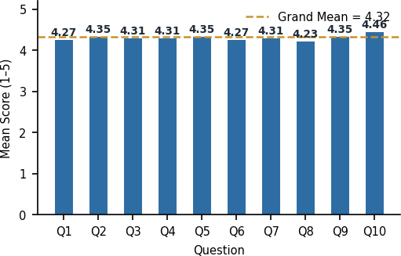
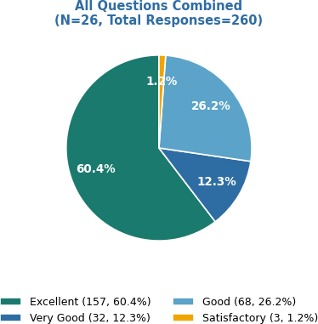

3. INDIVIDUAL QUESTION ANALYSIS
Q1 Depth of Course Content
Mean = 4.27 | SD = 0.874 | N = 26 | Remarks: Not Required

N | Mean | SD | Excellent 14 (53.8%) | Very Good 5 (19.2%) | Good  7 (26.9%) | Satisfactory 0 (0.0%) | Poor 0 (0.0%) | Remarks
26 | 4.27 | 0.874 | 14 | 5 | 7 | 0 | 0 | Not Required
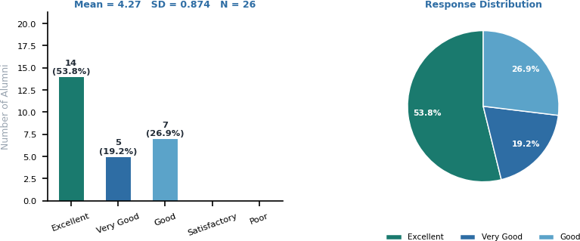

With a mean score of 4.27 (SD = 0.874), alumni express strong satisfaction with the depth of course content covered during their programmes. 14 respondents (53.8%) rated it Excellent and 5 (19.2%) Very Good — together accounting for 73.1% positive responses. 7 alumni (26.9%) rated it Good and none found it Satisfactory or Poor. This reflects confidence in the academic rigour of the courses offered.
Recommendation: The institution should continue to deepen course content, particularly in emerging subject areas. Introducing advanced electives and guest lectures by industry experts can further enhance content depth.

Q2 Coverage of Syllabus
Mean = 4.35 | SD = 0.892 | N = 26 | Remarks: Not Required

N | Mean | SD | Excellent 16 (61.5%) | Very Good 3 (11.5%) | Good  7 (26.9%) | Satisfactory 0 (0.0%) | Poor 0 (0.0%) | Remarks
26 | 4.35 | 0.892 | 16 | 3 | 7 | 0 | 0 | Not Required
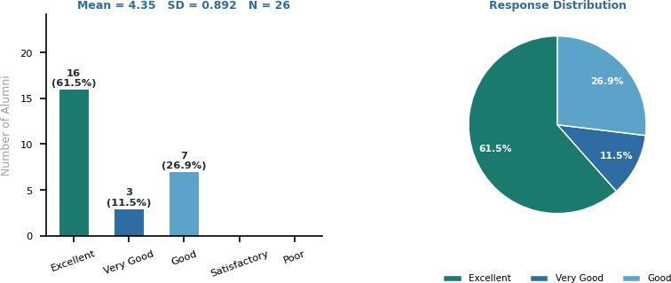

Coverage of syllabus received a mean of 4.35 (SD = 0.892). 16 alumni (61.5%) rated it Excellent, and 3 (11.5%) Very Good, combined 73.1% positive. 7 (26.9%) rated it Good and none rated it lower. This strong response indicates that alumni feel the syllabus comprehensively addressed the theoretical and practical dimensions of their respective disciplines.
Recommendation: Periodic syllabus reviews in consultation with faculty and industry stakeholders will help maintain this high satisfaction. Mapping syllabi against national academic frameworks (NEP 2020) is recommended.

Q3 Relevance for Employment / Higher Education
Mean = 4.31 | SD = 0.884 | N = 26 | Remarks: Not Required

N | Mean | SD | Excellent 15 (57.7%) | Very Good 4 (15.4%) | Good  7 (26.9%) | Satisfactory 0 (0.0%) | Poor 0 (0.0%) | Remarks

26 | 4.31 | 0.884 | 15 | 4 | 7 | 0 | 0 | Not Required
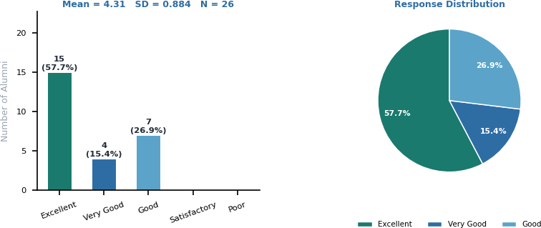

This component scores a mean of 4.31 (SD = 0.884). 15 alumni (57.7%) rated it Excellent, and 4 (15.4%) Very Good. 7 (26.9%) rated it Good and none rated it below Good. Alumni broadly affirm that their programmes equipped them well for employment, self-employment, and higher education, reflecting strong alignment between curriculum design and real-world outcomes.
Recommendation: The institution should strengthen industry linkages, career counselling services, and placement support. Tracking alumni employment data systematically through an alumni portal will provide richer insights for future curriculum planning.

Q4 Learning Values (Knowledge, Skills, Analytical Abilities)
Mean = 4.31 | SD = 0.884 | N = 26 | Remarks: Not Required

N | Mean | SD | Excellent 15 (57.7%) | Very Good 4 (15.4%) | Good  7 (26.9%) | Satisfactory 0 (0.0%) | Poor 0 (0.0%) | Remarks
26 | 4.31 | 0.884 | 15 | 4 | 7 | 0 | 0 | Not Required

Learning values scored a mean of 4.31 (SD = 0.884). 15 alumni (57.7%) rated it Excellent and 4 (15.4%) Very Good — combined 73.1% positive. 7 (26.9%) rated it Good. No negative ratings were recorded. Alumni acknowledge significant development of knowledge, skills, and analytical abilities through the curriculum.
Recommendation: The institution should continue outcome-based education approaches and integrate case studies, project work, and skill-building workshops to further enhance learning value across all programmes.

Q5 Clarity and Relevance of Reading Material
Mean = 4.35 | SD = 0.892 | N = 26 | Remarks: Not Required

N | Mean | SD | Excellent 16 (61.5%) | Very Good 3 (11.5%) | Good  7 (26.9%) | Satisfactory 0 (0.0%) | Poor 0 (0.0%) | Remarks
26 | 4.35 | 0.892 | 16 | 3 | 7 | 0 | 0 | Not Required

Clarity and relevance of reading material received a mean of 4.35 (SD = 0.892). 16 alumni (61.5%) rated it Excellent and 3 (11.5%) Very Good — combined 73.1% positive. 7 (26.9%) rated it Good, and no negative ratings were reported. Alumni are satisfied with the textbooks and reading resources provided during their courses.
Recommendation: The institution should regularly update prescribed textbooks, integrate digital reading resources, and ensure reference materials are aligned with current editions and industry-standard publications.

Q6 Availability of Study Material and Library Books
Mean = 4.27 | SD = 1.002 | N = 26 | Remarks: Not Required

N | Mean | SD | Excellent 16 (61.5%) | Very Good 2 (7.7%) | Good  7 (26.9%) | Satisfactory 1 (3.8%) | Poor 0 (0.0%) | Remarks
26 | 4.27 | 1.002 | 16 | 2 | 7 | 1 | 0 | Not Required
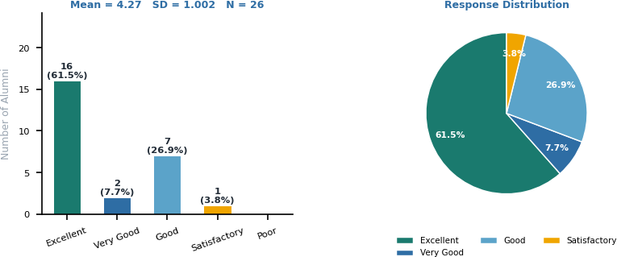

Availability of study material and library books scored a mean of 4.27 (SD = 1.002) — recording the highest standard deviation among all questions, indicating more varied alumni opinion. 16 alumni (61.5%) rated it Excellent, 2 (7.7%) Very Good, 7 (26.9%) Good, and 1 (3.8%) Satisfactory. The single Satisfactory rating signals an area warranting attention.
Recommendation: The institution should enhance library collections, expand digital resource subscriptions (e-journals, e-books), and ensure adequate availability of titles across all disciplines. Feedback-based library acquisition policies are recommended.

Q7 Relevance of the Curriculum
Mean = 4.31 | SD = 0.928 | N = 26 | Remarks: Not Required

N | Mean | SD | Excellent 16 (61.5%) | Very Good 2 (7.7%) | Good  8 (30.8%) | Satisfactory 0 (0.0%) | Poor 0 (0.0%) | Remarks
26 | 4.31 | 0.928 | 16 | 2 | 8 | 0 | 0 | Not Required
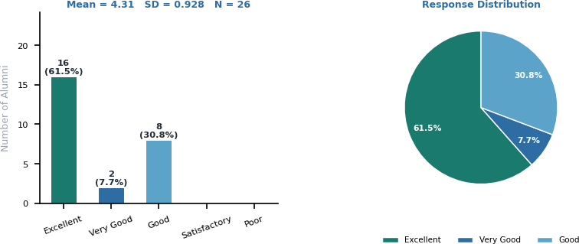

Relevance of the curriculum received a mean of 4.31 (SD = 0.928). 16 alumni (61.5%) rated it Excellent, 2 (7.7%) Very Good, and 8 (30.8%) Good. No negative responses were recorded. The strong endorsement of curriculum relevance from graduates — who have now experienced real-world application of their learning — is particularly meaningful validation.
Recommendation: The institution should establish a formal curriculum review committee with alumni participation to ensure continued alignment with evolving industry needs and academic developments.

Q8 Usefulness of Curriculum in Competitive Exams
Mean = 4.23 | SD = 0.992 | N = 26 | Remarks: Not Required

N | Mean | SD | Excellent 15 (57.7%) | Very Good 3 (11.5%) | Good  7 (26.9%) | Satisfactory 1 (3.8%) | Poor 0 (0.0%) | Remarks
26 | 4.23 | 0.992 | 15 | 3 | 7 | 1 | 0 | Not Required
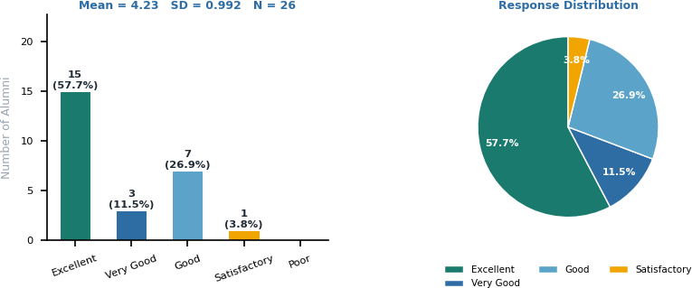

Usefulness for competitive exams scored a mean of 4.23 (SD = 0.992) — the joint lowest among curriculum questions, alongside the highest standard deviation — indicating the most diverse alumni opinion. 15 (57.7%) rated it Excellent, 3 (11.5%) Very Good, 7 (26.9%) Good, and 1 (3.8%) Satisfactory. While the majority are satisfied, a segment perceives scope for stronger competitive exam preparation integration.
Recommendation: The institution should consider introducing dedicated modules or coaching for competitive examinations such as KSET, NET, UPSC, and other relevant tests. Incorporating model question banks and mock assessments into coursework will enhance this perception.

Q9 Overall Rating
Mean = 4.35 | SD = 0.892 | N = 26 | Remarks: Not Required

N | Mean | SD | Excellent 16 (61.5%) | Very Good 3 (11.5%) | Good  7 (26.9%) | Satisfactory 0 (0.0%) | Poor 0 (0.0%) | Remarks
26 | 4.35 | 0.892 | 16 | 3 | 7 | 0 | 0 | Not Required

The overall rating of the curriculum received a mean of 4.35 (SD = 0.892). 16 alumni (61.5%) rated it Excellent and 3 (11.5%) Very Good, combined 73.1% positive. 7 (26.9%) rated it Good, and none gave a negative rating. This overall endorsement by graduates who have experienced the curriculum in practice is a strong indicator of institutional quality.
Recommendation: The institution should continue its IQAC-driven quality improvement cycle, maintaining high standards across all curriculum dimensions while addressing the specific areas flagged in this feedback.

Q10 Overall Procedure of Convocation Programme
Mean = 4.46 | SD = 0.905 | N = 26 | Remarks: Not Required

N | Mean | SD | Excellent 18 (69.2%) | Very Good 3 (11.5%) | Good  4 (15.4%) | Satisfactory 1 (3.8%) | Poor 0 (0.0%) | Remarks
26 | 4.46 | 0.905 | 18 | 3 | 4 | 1 | 0 | Not Required
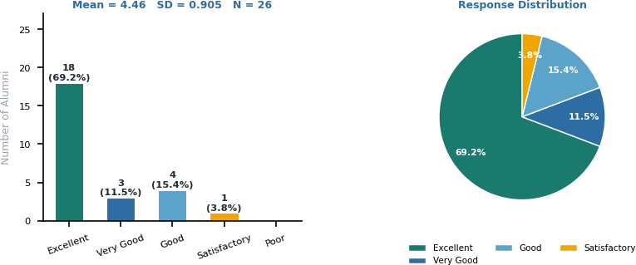

The overall convocation Programme procedure received the highest mean score of 4.46 (SD = 0.905). 18 alumni (69.2%) rated it Excellent and 3 (11.5%) Very Good — combined 80.8% positive. 4 (15.4%) rated it Good and 1 (3.8%) Satisfactory. Alumni expressed broad appreciation for the organisation and conduct of the 11th Convocation. One alumnus specifically suggested including an official class group photo as an enhancement.
Recommendation: The institution should continue maintaining the high ceremonial standards of the convocation and consider incorporating alumni suggestions, such as class group photographs and expanded networking opportunities to enrich the event.

4. ALUMNI SUGGESTIONS FOR CURRICULUM IMPROVEMENT

# | Suggestion | Theme
1 | More readable resource material | Academic Resources
2 | Focusing on all the main details of the course | Course Content
3 | Improve time management in curriculum delivery | Time Management / Pedagogy
4 | Need for reference books for subjects | Library / Academic Resources
5 | Create an environment where students are motivated to study | Motivation
6 | Work harder and build rigour in academics | Academic Rigour
7 | An official group photo with the whole class would have been good | Convocation / Event Management
A majority of alumni expressed satisfaction with the curriculum. Of the 26 respondents, 13 provided substantive suggestions, while others noted 'Nothing', 'All Good', or gave general praise. The themes of academic resources, student motivation, and course depth appear most frequently, consistent with findings from the quantitative analysis above.

5. CONCLUSION AND IQAC RECOMMENDATIONS
The 11th Convocation alumni feedback survey of St. Philomena's College (Autonomous) received responses from 26 graduates across seven programmes. All ten curriculum components received mean scores above 4.0 on a five-point scale, with a grand mean of 4.32 — reflecting highly positive alumni perception of the curriculum and institutional experience.
The highest-rated component was the Overall Procedure of the Convocation Programme (Q10: Mean = 4.46), followed by Coverage of Syllabus (Q2: Mean = 4.35), Clarity of Reading Material (Q5: Mean = 4.35), and Overall Rating (Q9: Mean = 4.35). The component with the highest standard deviation was Availability of Study Material (Q6: SD = 1.002), indicating more varied alumni opinion on library resources — a targeted area for improvement.
Regarding the K-SET/NET qualification field, all respondents left it blank, which is consistent with the demographics of recently graduated alumni. The institution is encouraged to track this metric longitudinally through alumni follow-up surveys conducted 1–2 years post-graduation.
The occupation data shows a balanced distribution — 42.3% of respondents are employed (in roles such as Quality Control Analyst, Assistant Professor, IT Professional, Medical Consultant, and Lecturer) and 42.3% are pursuing higher education. 11.5% are self-employed or entrepreneurs, and 3.8% belong to other categories. This reflects well-rounded career and academic outcomes for graduates of the institution.
# | IQAC Recommendation | Priority
1 | Enhance library collections and expand digital resource subscriptions (e-journals, e-books) to address the variation | High
2 | Integrate competitive examination preparation (KSET, NET, UPSC) into the curriculum through dedicated modules | High
3 | Establish a formal Alumni Curriculum Advisory Committee to provide ongoing feedback and ensure industry relevance | Medium
4 | Introduce more reference book titles per programme and maintain up-to-date prescribed reading lists. | Medium
5 | Track K-SET/NET qualification and employment outcomes through an annual alumni survey conducted 1–2 years after graduation | Medium
6 | Continue the IQAC annual feedback cycle; share analysis with department heads and incorporate recommendations | Low
7 | Incorporate alumni suggestions, such as group class photographs and expanded networking sessions in future events | Low

IQAC COORDINATOR IQAC ANALYST PRINCIPAL

Internal Quality Assurance Cell (IQAC) | ST. PHILOMENA'S COLLEGE (Autonomous) | Affiliated to the University of Mysore | Mysuru – 570 015

