REPORT ON STUDENT EXCHANGE PROGRAMME

ROADMAP TO YOUR DREAM JOB AND FINANCE FIESTA 2026

Under MOU follow-up activity between St. Philomena's College (Autonomous), Mysuru and St. Claret College (Autonomous), Bengaluru
Date: 03 June 2026
Venue: St. Philomena's College (Autonomous), Mysuru
Organized by: PG Department of Commerce, St. Philomena's College (Autonomous), Mysuru

Introduction
As part of the Memorandum of Understanding (MOU) between St. Philomena's College (Autonomous), Mysuru and St. Claret College (Autonomous), Bengaluru, a Students Exchange Programme was organized on 03 June 2026 at St. Philomena's College, Mysuru. The programme aimed at promoting academic collaboration, knowledge sharing, student interaction, and experiential learning between the two institutions.
The event brought together faculty members and students from both institutions, providing a platform for intellectual exchange, skill development, and collaborative learning.
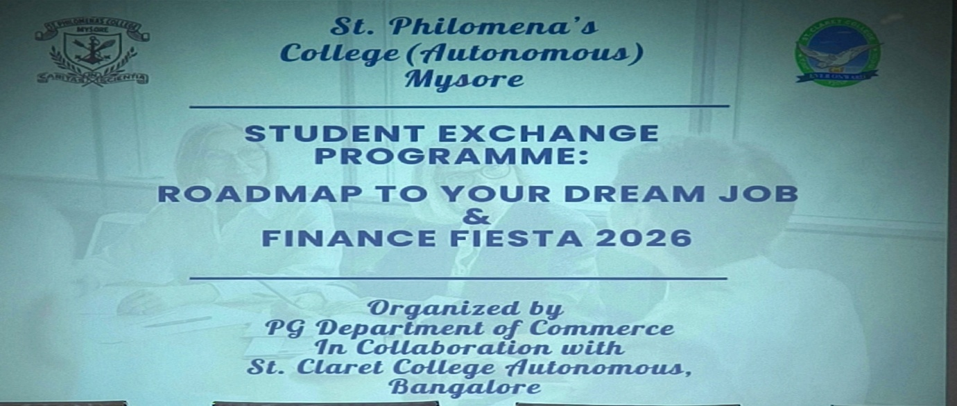

Dignitaries Present
The programme was graced by:
- Rev. Fr. Dr. Lourdu Prasad, Rector, St. Philomena's College (Autonomous), Mysuru
- Rev. Fr. Roshan S, Finance Officer, SPC
- Dr. Ravi Saldana, Principal, St. Philomena's College (Autonomous), Mysuru
- Dr. Noor Mubasheer, Coordinator
- Dr. Viveka Marie G., Head, PG Department of Commerce, St. Philomena's College (Autonomous), Mysuru
- Ms. Amrin Taj, Assistant Professor, PG Department of Commerce, St. Philomena's College (Autonomous), Mysuru
- Ms. Jayalakshmi, Assistant Professor, PG Department of Commerce, St. Philomena's College (Autonomous), Mysuru
Faculty members from St. Claret College (Autonomous), Bengaluru:
- Dr. Safeer Pasha, Head of the Department
- Dr. Harmeet Matharu, Associate Professor
- Dr. Radhat T., Assistant Professor
- Dr. Fatin, Associate Professor
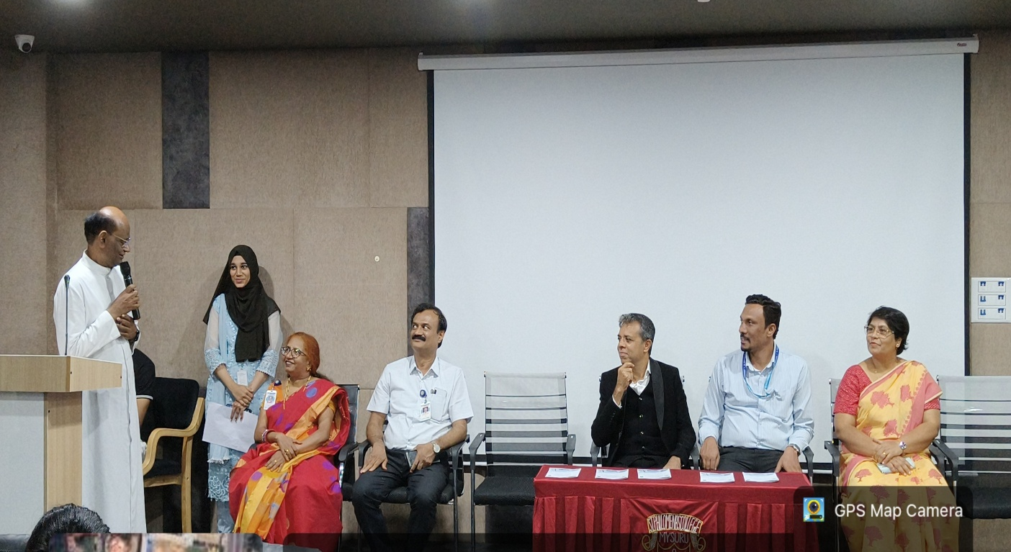

Academic Session
The programme commenced with an interactive academic session on the topic "Roadmap for Your Dream Job." The resource person provided valuable insights into career planning, employability skills, industry expectations, professional competencies, and strategies for achieving career goals.
The session encouraged students to identify their strengths, develop career-oriented skills, and understand the importance of continuous learning and professional development in a competitive employment market. Students from both St. Philomena's College and St. Claret College actively participated in the discussion and interacted with the resource person by raising questions related to career opportunities and future prospects.
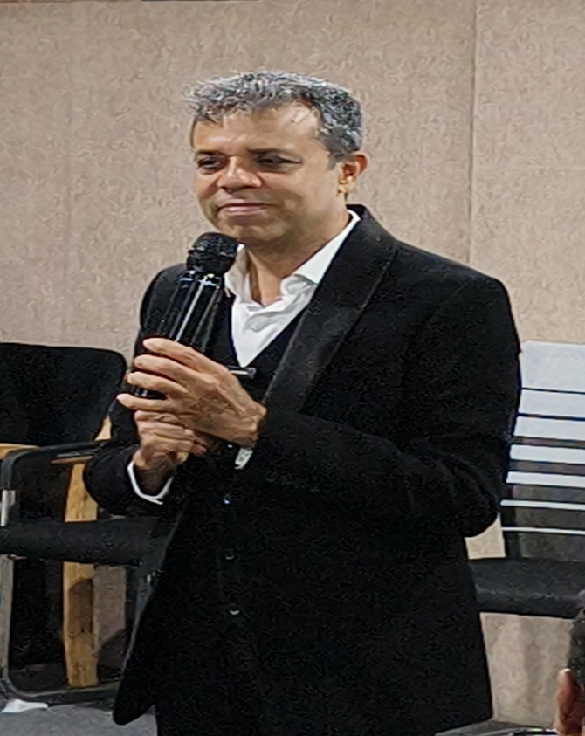
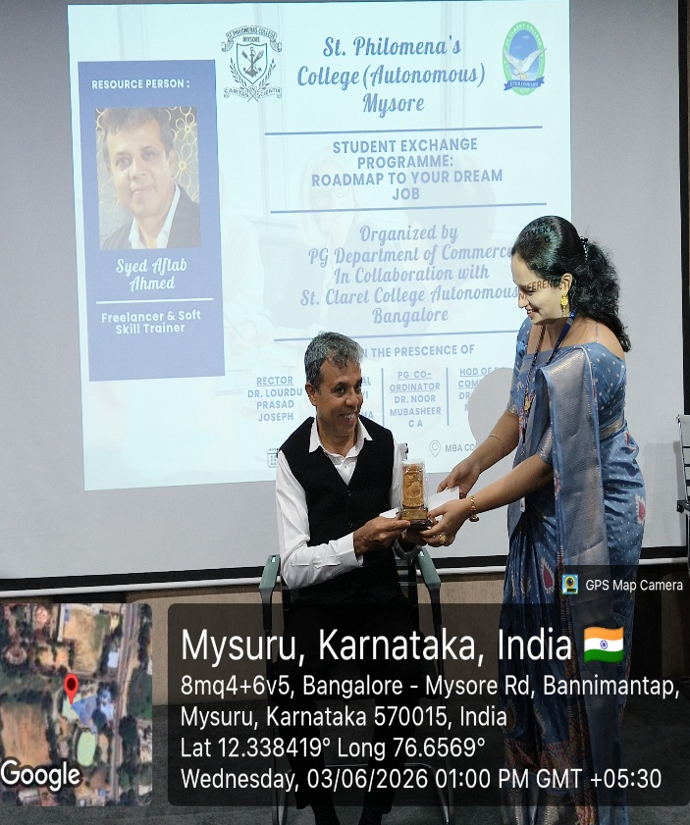

Finance Fiesta
Following the academic session, a series of engaging and knowledge-based activities were conducted under the banner "Finance Fiesta." The activities were designed to enhance financial literacy, analytical thinking, and teamwork among students.
1. Finance Quiz
A Finance Quiz competition was organized to test participants' knowledge of financial concepts, banking, investments, taxation, and contemporary economic developments. Students enthusiastically participated and demonstrated their understanding of finance-related topics.

2. Budgeting Activity
The Budgeting Activity challenged students to prepare practical and realistic budgets based on given scenarios. The activity encouraged participants to apply financial planning skills, resource allocation techniques, and decision-making abilities in real-life situations.

Mind Merchant Competition
The programme also featured "Mind Merchant," an innovative event that encouraged creativity, strategic thinking, and entrepreneurial skills among students.
The programme also featured an engaging event titled "Mind Merchant." The activity was designed to test students' awareness of brands, marketing strategies, and corporate identity.
During the competition, participants were shown various company logos and taglines and were required to correctly identify the respective companies. The activity challenged students' observation skills, brand recognition abilities, and knowledge of the business world.
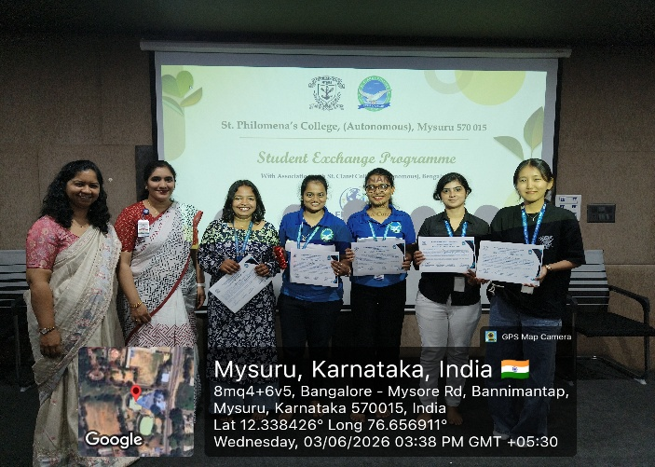
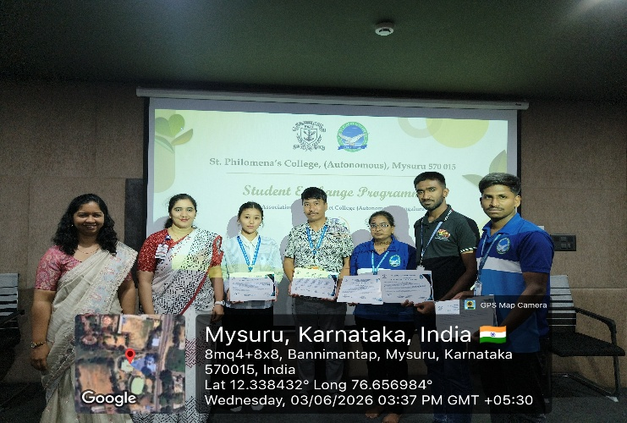
Students from both institutions participated enthusiastically and displayed a commendable understanding of well-known brands and their marketing communications. The event created a lively and competitive atmosphere while enhancing students' awareness of branding and promotional strategies adopted by companies.

Student Participation
Students from both institutions actively participated in all the sessions and competitions. The exchange programme facilitated meaningful interaction among students, enabling them to share ideas, experiences, and perspectives. The collaborative environment fostered mutual learning and strengthened inter-institutional relationships.
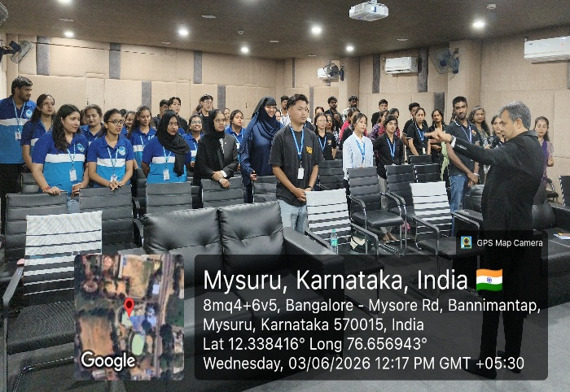
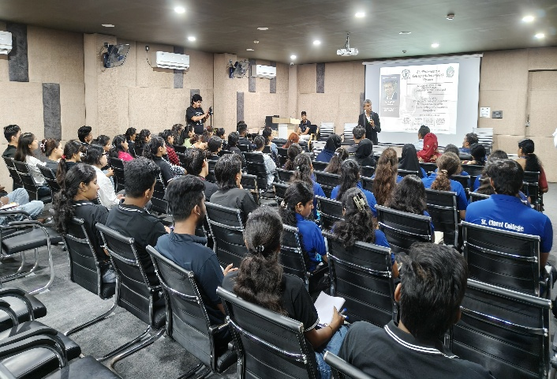

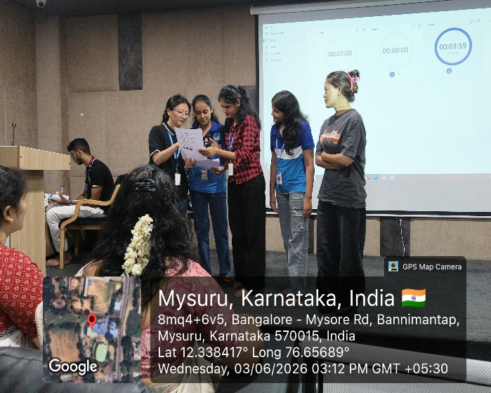
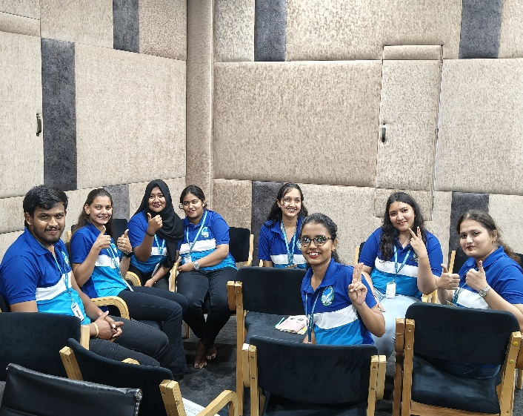

Outcomes of the Programme
The Students Exchange Programme successfully achieved its objectives by:
- Enhancing academic collaboration between the two institutions.
- Providing exposure to career planning and professional development.
- Improving students' financial literacy and analytical skills.
- Encouraging creativity, innovation, and entrepreneurial thinking.
- Promoting teamwork, communication, and leadership skills.
- Strengthening the partnership established through the MOU.
Conclusion
The Students Exchange Programme conducted on 03 June 2026 under the MOU between St. Philomena's College (Autonomous), Mysuru and St. Claret College (Autonomous), Bengaluru was highly informative and enriching. The programme offered students a valuable learning experience through academic discussions, finance-based activities, and entrepreneurial competitions. The event successfully fostered academic exchange, collaborative learning, and institutional cooperation, thereby contributing to the holistic development of students from both institutions.
